Math 760

# Chapter 7 HW

Gabrielle Salamanca

May 9, 2024

## 2. Given the data

## [,1] [,2] [,3] [,4] [,5] [,6]  
## z1 10 5 7 19 11 18  
## z2 2 3 3 6 7 9  
## y 15 9 3 25 7 13

## for the regression model $Y_{j}=β_{1}z_{j1}+β_{2}z_{j2}+ϵ_{i}$ (j = 1,2,…,6) to the standardized form of the variables y, $z_{1}$, $z_{2}$. From this fit, deduce the corresponding fitted regression equation for the original (not standardized) variables.

## The standardized form of the variables are:

## z1 z2 y  
## V1 0.2761327 -1.9329291 1.6567964  
## V2 -0.2697022 -1.0788089 1.3485112  
## V3 1.2408065 -0.6204032 -0.6204032  
## V4 0.5294141 -2.4201787 1.8907646  
## V5 1.2408065 -0.6204032 -0.6204032  
## V6 1.5539593 -1.4429622 -0.1109971

##   
## The mean of z1 is 0.7619028

## The mean of z2 is -1.352614

The fitted version of the equation $Y_{j}=β_{1}z_{j1}+β_{2}z_{j2}+ϵ_{i}$ is $\hat{y}={\hat{β}}_{1}z_{1}+{\hat{β}}_{2}z_{2}$. And with the results above, the fitted equation is: $\hat{y}=0.76z_{1}-1.35z_{2}$

Then, we find the values for the regular data to plug into the fitted equation. We will need the means and the square root of the diagonal of their covariance matrix.

## The mean for z1 is: 11.66667

## The mean for z2 is: 5

## The mean for y is: 12

## The square root covariance matrix of the predictors is:

## z1 z2 y  
## z1 5.715476 3.435113 5.692100  
## z2 3.435113 2.756810 2.097618  
## y 5.692100 2.097618 7.668116

Thus:

$$\frac{\hat{y}-12}{7.668116}=0.7619028\left(\frac{z_{1}-11.66667}{5.715476}\right)-1.352614\left(\frac{z_{2}-5}{2.756810}\right)$$

Let’s start with $z_{1}$

$$0.7619028\left(\frac{z_{1}-11.66667}{5.715476}\right)=0.1333052z_{1}-1.555228$$

Then $z_{2}$

$$-1.352614\left(\frac{z_{2}-5}{2.756810}\right)=-0.4906448z_{2}+2.453224$$

Putting that all back in,

$$⇒\frac{\hat{y}-12}{7.668116}=0.1333052z_{1}-1.555228-0.4906448z_{2}+2.453224$$

$$⇒\frac{\hat{y}-12}{7.668116}=0.1333052z_{1}-0.4906448z_{2}+0.897996$$

$$⇒\hat{y}-12=1.0222z_{1}-3.762321z_{2}+6.885937$$

$$⇒\hat{y}=1.0222z_{1}-3.762321z_{2}+18.88594$$

And simplifying that, we get: $\hat{y}=1.02z_{1}-3.76z_{2}+18.89$

## 8. Recall that that the hat matrix is defined by $H=Z{\left(Z'Z\right)}^{-1}Z'$ with diagonal elements $h_{j}j$.

### (a) Show that H is an idempotent matrix [See Result 7.1 and (7-6)]

**Result 7.1**

Let **Z** have full rank ($r+1≤n$). The least squares estimate of $β$ in (7-3) is given by: $\hat{β}={\left(Z'Z\right)}^{-1}Z'y$. Let $\hat{y}=Z\hat{β}=Hy$ denote the fitted values of y, where $H={\left(Z'Z\right)}^{-1}Z'$ is called “hat” matrix. Then the residuals $\hat{ϵ}=y-\hat{y}=\left[I-{\left(Z'Z\right)}^{-1}Z'\right]y=\left(I-H\right)y$ satisfy $Z'\hat{ϵ}=0$ and $\hat{y}'\hat{ϵ}=0$. Also, the residual sum of squares = $\sum_{j=1}^{n}{\left(y_{j}-{\hat{β}}_{0}-\hat{β_{1}}z_{j1}-...-\hat{β_{r}}z_{jr}\right)}=\hat{ϵ}'\hat{ϵ}=y'\left[I-Z{\left(Z'Z\right)}^{-1}Z'\right]y=y'y-y'Z\hat{β}$

**(7-6)**

$${\left[I-Z{\left(Z^{'}Z\right)}^{-1}Z^{'}\right]}^{'}\left[I-Z{\left(Z^{'}Z\right)}^{-1}Z^{'}\right]=I-2\left[Z{\left(Z^{'}Z\right)}^{-1}Z^{'}\right]+Z{\left(Z^{'}Z\right)}^{-1}Z^{'}\left[Z{\left(Z^{'}Z\right)}^{-1}Z^{'}\right]$$

${\left[I-Z{\left(Z^{'}Z\right)}^{-1}Z^{'}\right]}^{'}\left[I-Z{\left(Z^{'}Z\right)}^{-1}Z^{'}\right]=\left[I-Z{\left(Z'Z\right)}^{-1}Z'\right]$ (idempotent)

Thus, $H^{2}=Z{\left(Z'Z\right)}^{-1}Z'\left[Z{\left(Z'Z\right)}^{-1}Z'\right]=Z{\left(Z'Z\right)}^{-1}Z'=H$

### 

### (b) Show that $0<h_{jj}<1$ (j =1,2,…,n), and that $\sum_{j=1}^{n}{h_{jj}}=r+1$, where r is the number of independent variables in the regression model. (In fact, $\frac{1}{n}≤h_{jj}<1$)

Because [I-H] is an idempotent matrix, it’s a positive semidefinite. Then, let a be a $nx1$ unit vector with $j^{th}$ element 1. Then, $0≤a'\left(I-H\right)a=\left(1-h_{jj}\right)$; that is, $h_{jj}≤1$.

${\left(Z'Z\right)}^{-1}$ is a positive definite matrix. Thus $h_{jj}=b_{j}'{\left(Z'Z\right)}^{-1}b_{j}$, where $b_{j}$ is a the $j^{th}$ row of Z.

$$\sum_{i=1}^{r+1}{h_{jj}}=tr\left[Z{\left(Z'Z\right)}^{-1}Z'\right]=tr\left[{\left(Z'Z\right)}^{-1}\left(Z'Z\right)\right]=tr\left(I_{r+1}\right)=r+1$$

### 

### (c) Verify, for the simple linear regression model with one independent variable z, that the leverage $h_{jj}$ is given by $h_{jj}=\frac{1}{n}+\frac{{\left(z_{j}-\overset{‾}{z}\right)}^{2}}{\sum_{j=1}^{n}{{\left(z_{j}-\overset{‾}{z}\right)}^{2}}}$

Using

$${\left(Z'Z\right)}^{-1}=\frac{1}{n\sum_{i=1}^{n}{{\left(z_{j}-\overset{‾}{z}\right)}^{2}}}\left[\begin{matrix}\sum_{i=1}^{n}{z_{i}^{2}} & -\sum_{i=1}^{n}{z_{i}} \\ -\sum_{i=1}^{n}{z_{i}} & n\end{matrix}\right]$$

We get

$$h_{jj}=\left[\begin{matrix}1 & z_{j}\end{matrix}\right]{\left(Z'Z\right)}^{-1}\left[\begin{matrix}1 \\ z_{j}\end{matrix}\right]= \frac{1}{n\sum_{i=1}^{n}{{(z_{j}-\overline{z})}^{2}}}\left(\sum_{i=1}^{n}{z_{i}^{2}}-2z_{j}\sum_{i=1}^{n}{z_{i}}+nz_{j}^{2}\right)= \frac{1}{n}+\frac{{(z_{j}-\overline{z})}^{2}}{\sum_{i=1}^{n}{{(z_{j}-\overline{z})}^{2}}}$$

## 9. Consider the following data on one predictor variable $z_{1}$ and two responses $Y_{1}$ and $Y_{2}$

## [,1] [,2] [,3] [,4] [,5]  
## z1 -2 -1 0 1 2  
## y1 5 3 4 2 1  
## y2 -3 -1 -1 2 3

## 

## Determine the least squares estimates of the parameters in the bivariate straight-line regression model

$$Y_{j1}=β_{01}+β_{11}z_{j1}+ϵ_{j1}$$

$$Y_{j2}=β_{02}+β_{12}z_{j2}+ϵ_{j2}$$

## where j = 1,2,3,4,5. Also, calculate the matrices of fitted values $\hat{Y}$ and residuals $\hat{ϵ}$ with $Y=\left[y_{1}|y_{2}\right]$. Verify the sum of squares and cross-products decomposition $Y'Y=\hat{Y'}\hat{Y}+\hat{ϵ'}\hat{ϵ}$

To find the least squares estimate of the $β's$, we use $\hat{β}={\left(Z'Z\right)}^{-1}Z'y$. Let’s find our Z’s.

## The Z matrix is

## [,1] [,2]  
## [1,] 1 -2  
## [2,] 1 -1  
## [3,] 1 0  
## [4,] 1 1  
## [5,] 1 2

##   
## The inverse of Z'Z is

## [,1] [,2]  
## [1,] 0.2 0.0  
## [2,] 0.0 0.1

Now, let’s find our $β's$.

## Our least squares estimates matrix of our parameters is

## [,1] [,2]  
## [1,] 3.0 1.110223e-16  
## [2,] -0.9 1.500000e+00

We’ll now calculate the matrices of fitted values $\hat{Y}$, which is calculated by multiplying $Z$ and $\hat{β}$.

## [,1] [,2]  
## [1,] 4.8 -3.000000e+00  
## [2,] 3.9 -1.500000e+00  
## [3,] 3.0 1.110223e-16  
## [4,] 2.1 1.500000e+00  
## [5,] 1.2 3.000000e+00

Finally, we’ll calculate the residuals $\hat{ϵ}$ with $Y=\left[y_{1}|y_{2}\right]$. It’s calculated by subtracting $Y$ and $\hat{Y}$.

## The residual matrix is

## [,1] [,2]  
## [1,] 0.2 4.440892e-16  
## [2,] -0.9 5.000000e-01  
## [3,] 1.0 -1.000000e+00  
## [4,] -0.1 5.000000e-01  
## [5,] -0.2 -4.440892e-16

After all that, we must verify the sum of squares and cross-products decomposition with this equation: $Y'Y=\hat{Y'}\hat{Y}+\hat{ϵ'}\hat{ϵ}$

## The Y'Y matrix is

## [,1] [,2]  
## [1,] 55 -15  
## [2,] -15 24

##   
## The right side of the equation is

## [,1] [,2]  
## [1,] 55 -15  
## [2,] -15 24

## 

## 12. Given the mean vector and covariance of Y, $Z_{1}$, and $Z_{2}$. Determine each of the following.

## mu Matrix

## [,1]  
## [1,] 4  
## [2,] 3  
## [3,] -2

##   
## Sigma matrix

## [,1] [,2] [,3]  
## [1,] 9 3 1  
## [2,] 3 2 1  
## [3,] 1 1 1

## 

### (a) The best linear predictor $β_{0}+β_{1}Z_{1}+β_{2}Z_{2}$ of Y

To find $β$ and $β_{0}$, we use these equations: $β=Σ_{ZZ}^{-1}σ_{ZY}$, $β_{0}=μ_{Y}-β'μ_{Z}$

## Our beta matrix is

## [,1]  
## [1,] 2  
## [2,] -1

##   
## Beta-0 is -4

Our model is: $Y=β_{0}+β_{1}Z_{1}+β_{2}Z_{2}=-4+2z_{1}-z_{2}$

### 

### (b) The mean square error of the best linear predictor

This is calculated with this equation: $σ_{yy}-σ'_{zy}Σ_{ZZ}^{-1}σ_{ZY}$

## [,1]  
## [1,] 4

### 

### (c) The population multiple correlation coefficient

This is calculated as such: $ρ_{Y\left(x\right)}=\sqrt{\frac{σ'_{zy}Σ_{ZZ}^{-1}σ_{ZY}}{σ_{YY}}}$

## [,1]  
## [1,] 0.745356

### 

### (d) The partial correlation coefficient $ρ_{YZ_{1}*Z_{2}}$

The partial correlation coefficient formula is provided by (7-56):

$$ρ_{Y_{1}Y_{2}*Z}=\frac{σ_{Y_{1}Y_{2}*Z}}{\sqrt{σ_{Y_{1}Y_{1}*Z}}\sqrt{σ_{Y_{2}Y_{2}*Z}}}$$

We’ll first need to partition our $Σ$ matrix and determine to covariance of $\left[\begin{matrix}Y \\ Z_{1}\end{matrix}\right]$.

$$\left(\begin{matrix}9 & 3 & | & 1 \\ 3 & 2 & | & 1 \\ - & - & + & - \\ 1 & 1 & | & 1\end{matrix}\right)$$

## The covariance matrix is

## [,1] [,2]  
## [1,] 8 2  
## [2,] 2 1

Now, $ρ_{Y_{1}Y_{2}*Z}$ is

## [1] 0.7071068

## 

## 17. Consider the Forbes data in Exercise 1.4

## order sales profits assets  
## [1,] 1 108.28 17.05 1484.10  
## [2,] 2 152.36 16.59 750.33  
## [3,] 3 95.04 10.91 766.42  
## [4,] 4 65.45 14.14 1110.46  
## [5,] 5 62.97 9.52 1031.29  
## [6,] 6 263.99 25.33 195.26  
## [7,] 7 265.19 18.54 193.83  
## [8,] 8 285.06 15.73 191.11  
## [9,] 9 92.01 8.10 1175.16  
## [10,] 10 165.68 11.13 211.15

### 

### (a) Fit a linear regression model to these data using profits as the dependent variable and sales and assets as the indepedent variables.

##   
## Call:  
## lm(formula = profits ~ sales + assets)  
##   
## Residuals:  
## Min 1Q Median 3Q Max   
## -4.954 -1.215 -0.316 1.686 6.224   
##   
## Coefficients:  
## Estimate Std. Error t value Pr(>|t|)   
## (Intercept) 0.013325 7.641453 0.002 0.9987   
## sales 0.068058 0.027851 2.444 0.0445 *  
## assets 0.005768 0.004946 1.166 0.2817   
## ---  
## Signif. codes: 0 '***' 0.001 '**' 0.01 '*' 0.05 '.' 0.1 ' ' 1  
##   
## Residual standard error: 3.863 on 7 degrees of freedom  
## Multiple R-squared: 0.5569, Adjusted R-squared: 0.4303   
## F-statistic: 4.399 on 2 and 7 DF, p-value: 0.05792

The linear regression model is: $Y=0.013325+0.068058x_{1}+0.005768x_{3}$

### 

### (b) Analyze the residuals to check the adequacy of the model. Compute the leverages associated with the data points. Does one (or more) of these companies stand out as an outlier in the set of independent variable data points?

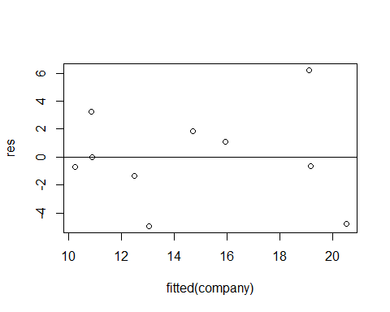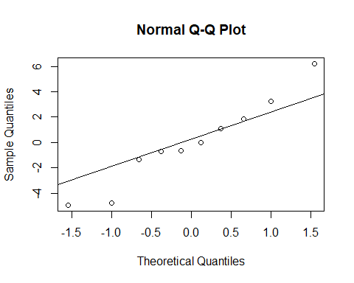

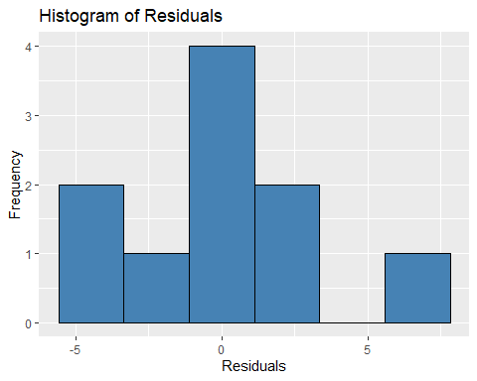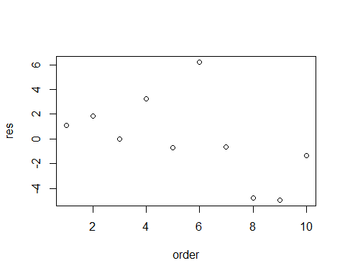

Given the small sample size, I would say the data is independent, but I would caution about it following a normal distribution due to 3 points being quite far from the line. However, the histogram does give the vague bell-shape curve, even if there’s an empty space.

## The average leverage is 0.9

## hatvalues(company)  
## 1 0.6256557  
## 2 0.1010997  
## 3 0.2432703  
## 4 0.2222081  
## 5 0.2512938  
## 6 0.2745888  
## 7 0.2785075  
## 8 0.3642405  
## 9 0.2029422  
## 10 0.4361935

We see that most of the leverage values are less than 0.9, which means there are no unusual observations.

### (c) Generate a 95% prediction interval for profits corresponding to sales of 100 (billions of dollars) and assets of 500 (billion off dollars).

Here’s what we know:

From (a), $Y=0.013325+0.068058x_{1}+0.005768x_{3}$

sales, $x_{1}=100$

assets, $x_{3}=500$

The 95% prediction interval for profits is:

## fit lwr upr  
## 1 9.703207 -1.545611 20.95203

### 

### (d) Carry out a likelihood ratio test of $H_{0}:β_{2}=0$ with significance level of $α=0.05$. Should the original model be modified. Discuss.

$H_{0}:β_{2}=0$ vs $H_{1}:β_{2}≠0$

## Likelihood ratio test  
##   
## Model 1: profits ~ sales  
## Model 2: profits ~ sales + assets  
## #Df LogLik Df Chisq Pr(>Chisq)  
## 1 3 -26.808   
## 2 4 -25.920 1 1.7755 0.1827

The $χ^{2}$ p-value is 0.1827, which is greater than $α=0.05$, so we cannot reject $H_{0}$. If we wanted to fit a model to fit our data better, we should consider only having sales as a predictor for profits.

## 22. Using the data on bone mineral content in Table 1.8

### (a) Perform a regression analysis by fitting the response for the dominant radius bone to the measurements on the last four bones

When we perform a regression analysis of $DomRad= DomHum+ Hum + DomUlna + Ulna$, our results are:

##   
## Call:  
## lm(formula = domRad ~ domHum + hum + domUln + ulna)  
##   
## Residuals:  
## Min 1Q Median 3Q Max   
## -0.131062 -0.028098 0.000606 0.035727 0.134517   
##   
## Coefficients:  
## Estimate Std. Error t value Pr(>|t|)   
## (Intercept) 0.1027 0.1064 0.966 0.3457   
## domHum 0.2756 0.1147 2.402 0.0261 *  
## hum -0.1652 0.1381 -1.196 0.2458   
## domUln 0.3566 0.1985 1.796 0.0876 .  
## ulna 0.4068 0.2174 1.871 0.0760 .  
## ---  
## Signif. codes: 0 '***' 0.001 '**' 0.01 '*' 0.05 '.' 0.1 ' ' 1  
##   
## Residual standard error: 0.06635 on 20 degrees of freedom  
## Multiple R-squared: 0.7178, Adjusted R-squared: 0.6614   
## F-statistic: 12.72 on 4 and 20 DF, p-value: 2.617e-05

#### 

#### (i) Suggest and fit appropriate linear regression models.

Based on the results, it would be best to remove the humerus variable, and possibly also both ulna variables. We’ll run one with both ulnas and one without them.

##   
## Call:  
## lm(formula = domRad ~ domHum + domUln + ulna)  
##   
## Residuals:  
## Min 1Q Median 3Q Max   
## -0.152610 -0.027960 -0.002006 0.027820 0.144917   
##   
## Coefficients:  
## Estimate Std. Error t value Pr(>|t|)   
## (Intercept) 0.11013 0.10728 1.027 0.3163   
## domHum 0.15685 0.05802 2.704 0.0133 *  
## domUln 0.36044 0.20054 1.797 0.0867 .  
## ulna 0.28621 0.19453 1.471 0.1560   
## ---  
## Signif. codes: 0 '***' 0.001 '**' 0.01 '*' 0.05 '.' 0.1 ' ' 1  
##   
## Residual standard error: 0.06703 on 21 degrees of freedom  
## Multiple R-squared: 0.6977, Adjusted R-squared: 0.6545   
## F-statistic: 16.15 on 3 and 21 DF, p-value: 1.13e-05

##   
## Call:  
## lm(formula = domRad ~ domHum)  
##   
## Residuals:  
## Min 1Q Median 3Q Max   
## -0.14320 -0.05436 0.02160 0.03806 0.16288   
##   
## Coefficients:  
## Estimate Std. Error t value Pr(>|t|)   
## (Intercept) 0.34520 0.10992 3.141 0.004584 **   
## domHum 0.27813 0.06059 4.590 0.000129 ***  
## ---  
## Signif. codes: 0 '***' 0.001 '**' 0.01 '*' 0.05 '.' 0.1 ' ' 1  
##   
## Residual standard error: 0.08414 on 23 degrees of freedom  
## Multiple R-squared: 0.4781, Adjusted R-squared: 0.4554   
## F-statistic: 21.07 on 1 and 23 DF, p-value: 0.0001292

It looks like with only the dominant humerus as a predictor, the model is the best fit. Though, I will bring to attention to the $R^{2}$ values for the no-ulna model. They are notably smaller than the one where we included the ulnas.

So, let’s also try with one ulna each just to see if our $R^{2}$ values are better.

##   
## Call:  
## lm(formula = domRad ~ domHum + domUln)  
##   
## Residuals:  
## Min 1Q Median 3Q Max   
## -0.14058 -0.03802 -0.01424 0.03132 0.14739   
##   
## Coefficients:  
## Estimate Std. Error t value Pr(>|t|)   
## (Intercept) 0.1637 0.1035 1.581 0.12808   
## domHum 0.1625 0.0594 2.735 0.01208 *   
## domUln 0.5519 0.1566 3.525 0.00191 **  
## ---  
## Signif. codes: 0 '***' 0.001 '**' 0.01 '*' 0.05 '.' 0.1 ' ' 1  
##   
## Residual standard error: 0.06878 on 22 degrees of freedom  
## Multiple R-squared: 0.6665, Adjusted R-squared: 0.6362   
## F-statistic: 21.98 on 2 and 22 DF, p-value: 5.676e-06

##   
## Call:  
## lm(formula = domRad ~ domHum + ulna)  
##   
## Residuals:  
## Min 1Q Median 3Q Max   
## -0.162158 -0.029020 -0.005463 0.052344 0.134185   
##   
## Coefficients:  
## Estimate Std. Error t value Pr(>|t|)   
## (Intercept) 0.13624 0.11155 1.221 0.23490   
## domHum 0.19610 0.05641 3.476 0.00214 **  
## ulna 0.51311 0.15532 3.303 0.00324 **  
## ---  
## Signif. codes: 0 '***' 0.001 '**' 0.01 '*' 0.05 '.' 0.1 ' ' 1  
##   
## Residual standard error: 0.07034 on 22 degrees of freedom  
## Multiple R-squared: 0.6512, Adjusted R-squared: 0.6194   
## F-statistic: 20.53 on 2 and 22 DF, p-value: 9.309e-06

Both of these models are better than the no-ulna model based on the $R^{2}$ values. If one had to choose, the model with the dominant bones would be the best: $DomRad=0.1637+0.1625 DomHum +0.5519 DomUlna$

#### (ii) Analyze the residuals

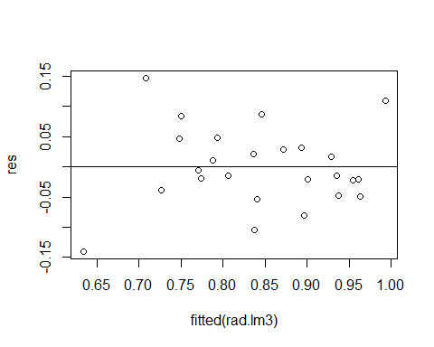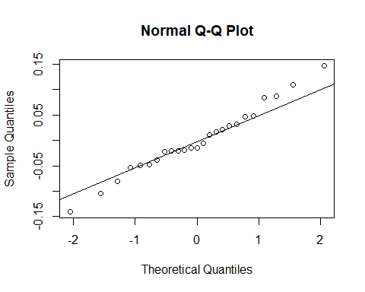

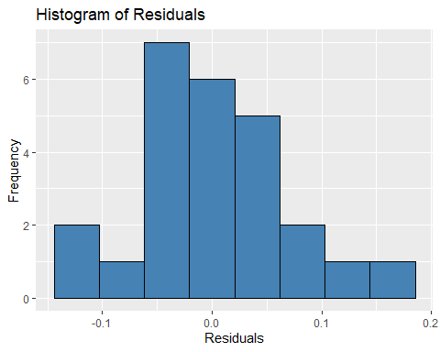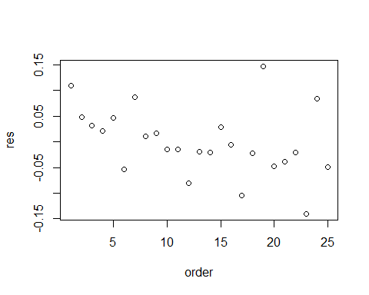

From these plots, it generally follows a normal distribution, but I would want to be careful of certain points that stray a bit from the line in the fitted values and order plots.

### (b) Perform a multivariate multiple regression analysis by fitting the responses from both radius bones.

## Response domRad :  
##   
## Call:  
## lm(formula = domRad ~ domHum + hum + domUln + ulna, data = bone)  
##   
## Residuals:  
## Min 1Q Median 3Q Max   
## -0.131062 -0.028098 0.000606 0.035727 0.134517   
##   
## Coefficients:  
## Estimate Std. Error t value Pr(>|t|)   
## (Intercept) 0.1027 0.1064 0.966 0.3457   
## domHum 0.2756 0.1147 2.402 0.0261 *  
## hum -0.1652 0.1381 -1.196 0.2458   
## domUln 0.3566 0.1985 1.796 0.0876 .  
## ulna 0.4068 0.2174 1.871 0.0760 .  
## ---  
## Signif. codes: 0 '***' 0.001 '**' 0.01 '*' 0.05 '.' 0.1 ' ' 1  
##   
## Residual standard error: 0.06635 on 20 degrees of freedom  
## Multiple R-squared: 0.7178, Adjusted R-squared: 0.6614   
## F-statistic: 12.72 on 4 and 20 DF, p-value: 2.617e-05  
##   
##   
## Response rad :  
##   
## Call:  
## lm(formula = rad ~ domHum + hum + domUln + ulna, data = bone)  
##   
## Residuals:  
## Min 1Q Median 3Q Max   
## -0.110436 -0.037494 0.008991 0.040042 0.089457   
##   
## Coefficients:  
## Estimate Std. Error t value Pr(>|t|)   
## (Intercept) 0.11423 0.08971 1.273 0.2175   
## domHum -0.01103 0.09676 -0.114 0.9104   
## hum 0.15204 0.11649 1.305 0.2067   
## domUln 0.19764 0.16743 1.180 0.2517   
## ulna 0.46247 0.18333 2.523 0.0202 *  
## ---  
## Signif. codes: 0 '***' 0.001 '**' 0.01 '*' 0.05 '.' 0.1 ' ' 1  
##   
## Residual standard error: 0.05595 on 20 degrees of freedom  
## Multiple R-squared: 0.7715, Adjusted R-squared: 0.7258   
## F-statistic: 16.88 on 4 and 20 DF, p-value: 3.378e-06

When running the multivariate multiple regression analysis, we find that the one with radius is the better model, especially considering the $R^{2}$ values.

### 

### (c) Calculate the AIC for the model you chose in (b) and for the full model.

## The AIC for the model domRad = domHum + domUln is -58.0937

## The AIC for the model rad = domHum + hum + domUln + ulna is -66.79644

## 

## 25. Amitriptyline is prescribed by some physicians as an antidepressant. However, there are also conjectured side effects that seem to be related to the use of the drug: irregular heartbeat, abnormal blood pressures, and irregular waves on the electrocardiogram, among other things. Data gathered on 17 patients who were admitted to the hospital after an amitriptyline overdose are given in Table 7.6. The two response variables are:

$Y_{1}=$ Total TCAD plasma level (TOT)

$Y_{2}=$ Amount of amitriptyline present in TCAD plasma level (AMI)

## The five predictor variables are:

$Z_{1}$ = Gender, where fem = 1 and male = 0 (GEN)

$Z_{2}$ = Amount of antidepressants taken at time of overdose (AMT)

$Z_{3}$ = PR wave measurement (PR)

$Z_{4}$ = Diastolic blood pressure (DIAP)

$Z_{5}$ = QRS wave measurement (QRS)

### 

### (a) Perform a regression analysis using only the first response $Y_{1}$

##   
## Call:  
## lm(formula = y1 ~ z1 + z2 + z3 + z4 + z5, data = drug)  
##   
## Residuals:  
## Min 1Q Median 3Q Max   
## -399.2 -180.1 4.5 164.1 366.8   
##   
## Coefficients:  
## Estimate Std. Error t value Pr(>|t|)   
## (Intercept) -2.879e+03 8.933e+02 -3.224 0.008108 **   
## z1 6.757e+02 1.621e+02 4.169 0.001565 **   
## z2 2.848e-01 6.091e-02 4.677 0.000675 ***  
## z3 1.027e+01 4.255e+00 2.414 0.034358 *   
## z4 7.251e+00 3.225e+00 2.248 0.046026 *   
## z5 7.598e+00 3.849e+00 1.974 0.074006 .   
## ---  
## Signif. codes: 0 '***' 0.001 '**' 0.01 '*' 0.05 '.' 0.1 ' ' 1  
##   
## Residual standard error: 281.2 on 11 degrees of freedom  
## Multiple R-squared: 0.8871, Adjusted R-squared: 0.8358   
## F-statistic: 17.29 on 5 and 11 DF, p-value: 6.983e-05

When running a regression analysis on the full model with $Y_{1}$ as the response, we find that $Z_{5}$ isn’t as significant at $α=0.05$, so we could drop that variable.

#### 

#### Suggest and fit appropriate linear regression models.

Let’s see an anova to see which variables to keep.

## Analysis of Variance Table  
##   
## Response: y1  
## Df Sum Sq Mean Sq F value Pr(>F)   
## z1 1 288658 288658 3.6497 0.08248 .   
## z2 1 5616926 5616926 71.0179 3.97e-06 ***  
## z3 1 341134 341134 4.3131 0.06204 .   
## z4 1 280973 280973 3.5525 0.08613 .   
## z5 1 308241 308241 3.8973 0.07401 .   
## Residuals 11 870008 79092   
## ---  
## Signif. codes: 0 '***' 0.001 '**' 0.01 '*' 0.05 '.' 0.1 ' ' 1

After running anova, we find that the model with only $Z_{2}$ is our best fit. Let’s see if that’s true.

##   
## Call:  
## lm(formula = y1 ~ z2, data = drug)  
##   
## Residuals:  
## Min 1Q Median 3Q Max   
## -1061.05 -139.23 51.19 203.25 627.51   
##   
## Coefficients:  
## Estimate Std. Error t value Pr(>|t|)   
## (Intercept) 462.8928 160.9090 2.877 0.0115 *   
## z2 0.3065 0.0578 5.303 8.86e-05 ***  
## ---  
## Signif. codes: 0 '***' 0.001 '**' 0.01 '*' 0.05 '.' 0.1 ' ' 1  
##   
## Residual standard error: 422.8 on 15 degrees of freedom  
## Multiple R-squared: 0.6521, Adjusted R-squared: 0.6289   
## F-statistic: 28.12 on 1 and 15 DF, p-value: 8.861e-05

All are significant, but I do want to try adding $Z_{1}$ to see if our $R^{2}$ values are better.

##   
## Call:  
## lm(formula = y1 ~ z1 + z2, data = drug)  
##   
## Residuals:  
## Min 1Q Median 3Q Max   
## -756.05 -190.68 -59.83 203.32 560.84   
##   
## Coefficients:  
## Estimate Std. Error t value Pr(>|t|)   
## (Intercept) 56.72005 206.70337 0.274 0.7878   
## z1 507.07308 193.79082 2.617 0.0203 *   
## z2 0.32896 0.04978 6.609 1.17e-05 ***  
## ---  
## Signif. codes: 0 '***' 0.001 '**' 0.01 '*' 0.05 '.' 0.1 ' ' 1  
##   
## Residual standard error: 358.6 on 14 degrees of freedom  
## Multiple R-squared: 0.7664, Adjusted R-squared: 0.733   
## F-statistic: 22.96 on 2 and 14 DF, p-value: 3.8e-05

The $R^{2}$ values are better, even if the intercept wasn’t significant. Let’s try with the other variables just to make sure.

##   
## Call:  
## lm(formula = y1 ~ z1 + z2 + z3, data = drug)  
##   
## Residuals:  
## Min 1Q Median 3Q Max   
## -597.48 -189.26 -61.15 204.74 552.22   
##   
## Coefficients:  
## Estimate Std. Error t value Pr(>|t|)   
## (Intercept) -1.328e+03 8.174e+02 -1.625 0.12824   
## z1 5.582e+02 1.834e+02 3.044 0.00942 **  
## z2 2.583e-01 6.169e-02 4.187 0.00106 **  
## z3 8.578e+00 4.921e+00 1.743 0.10487   
## ---  
## Signif. codes: 0 '***' 0.001 '**' 0.01 '*' 0.05 '.' 0.1 ' ' 1  
##   
## Residual standard error: 335 on 13 degrees of freedom  
## Multiple R-squared: 0.8106, Adjusted R-squared: 0.7669   
## F-statistic: 18.55 on 3 and 13 DF, p-value: 5.575e-05

##   
## Call:  
## lm(formula = y1 ~ z1 + z2 + z3 + z4, data = drug)  
##   
## Residuals:  
## Min 1Q Median 3Q Max   
## -360.64 -192.74 -44.95 239.31 435.62   
##   
## Coefficients:  
## Estimate Std. Error t value Pr(>|t|)   
## (Intercept) -2.154e+03 9.071e+02 -2.374 0.035121 *   
## z1 6.505e+02 1.800e+02 3.614 0.003555 **   
## z2 3.126e-01 6.603e-02 4.735 0.000485 ***  
## z3 1.049e+01 4.739e+00 2.214 0.046955 *   
## z4 5.951e+00 3.518e+00 1.692 0.116499   
## ---  
## Signif. codes: 0 '***' 0.001 '**' 0.01 '*' 0.05 '.' 0.1 ' ' 1  
##   
## Residual standard error: 313.3 on 12 degrees of freedom  
## Multiple R-squared: 0.8471, Adjusted R-squared: 0.7961   
## F-statistic: 16.62 on 4 and 12 DF, p-value: 7.772e-05

##   
## Call:  
## lm(formula = y1 ~ z1, data = drug)  
##   
## Residuals:  
## Min 1Q Median 3Q Max   
## -608.6 -418.6 -137.6 192.4 2184.4   
##   
## Coefficients:  
## Estimate Std. Error t value Pr(>|t|)   
## (Intercept) 918.6 314.5 2.921 0.0105 *  
## z1 286.0 374.3 0.764 0.4567   
## ---  
## Signif. codes: 0 '***' 0.001 '**' 0.01 '*' 0.05 '.' 0.1 ' ' 1  
##   
## Residual standard error: 703.2 on 15 degrees of freedom  
## Multiple R-squared: 0.03746, Adjusted R-squared: -0.02671   
## F-statistic: 0.5838 on 1 and 15 DF, p-value: 0.4567

Comparing all these models, the one with 2 predictors is the best.

##   
## Call:  
## lm(formula = y1 ~ z1 + z2, data = drug)  
##   
## Coefficients:  
## (Intercept) z1 z2   
## 56.720 507.073 0.329

#### Analyze the residuals

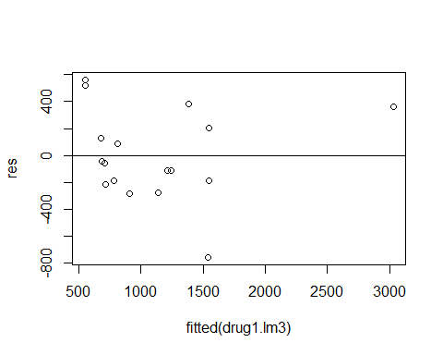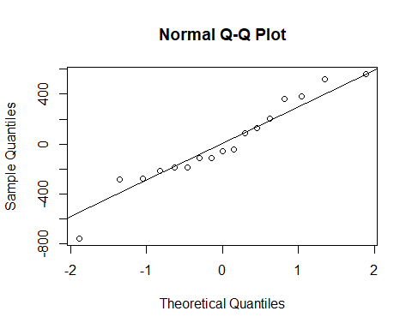

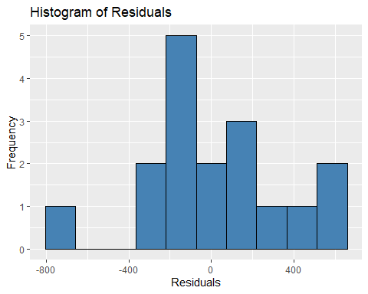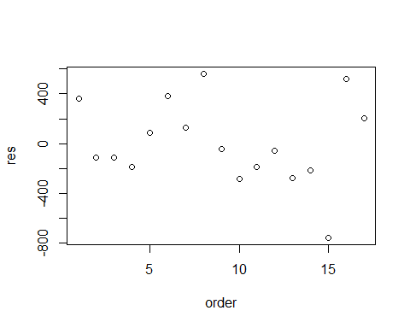

I would say the residuals are independent and follow a normal distribution, but I do spy an outlier.

#### Construct a 95% prediction interval for Total TCAD for $z_{1}=1$, $z_{2}=1200$, $z_{3}=140$, $z_{4}=70$, and $z_{5}=85$.

## The 95% prediction interval is:

## fit lwr upr  
## 1 958.5473 154.0402 1763.054

### 

### (b) Repeat (a) using the second response $Y_{2}$

## Analysis of Variance Table  
##   
## Response: y2  
## Df Sum Sq Mean Sq F value Pr(>F)   
## z1 1 532382 532382 6.2253 0.02977 *   
## z2 1 5457338 5457338 63.8143 6.623e-06 ***  
## z3 1 227012 227012 2.6545 0.13153   
## z4 1 320151 320151 3.7436 0.07913 .   
## z5 1 132786 132786 1.5527 0.23862   
## Residuals 11 940709 85519   
## ---  
## Signif. codes: 0 '***' 0.001 '**' 0.01 '*' 0.05 '.' 0.1 ' ' 1

Even if we change the response variable, we still find that having only two predictors, $Z_{1}$ and $Z_{2}$, is the best fit, even if the intercept isn’t significant as shown below.

##   
## Call:  
## lm(formula = y2 ~ z1 + z2, data = drug)  
##   
## Residuals:  
## Min 1Q Median 3Q Max   
## -716.80 -135.83 -23.16 182.27 695.97   
##   
## Coefficients:  
## Estimate Std. Error t value Pr(>|t|)   
## (Intercept) -241.34791 196.11640 -1.231 0.23874   
## z1 606.30967 183.86521 3.298 0.00529 **   
## z2 0.32425 0.04723 6.866 7.73e-06 ***  
## ---  
## Signif. codes: 0 '***' 0.001 '**' 0.01 '*' 0.05 '.' 0.1 ' ' 1  
##   
## Residual standard error: 340.2 on 14 degrees of freedom  
## Multiple R-squared: 0.787, Adjusted R-squared: 0.7566   
## F-statistic: 25.87 on 2 and 14 DF, p-value: 1.986e-05

##   
## Our model is

##   
## Call:  
## lm(formula = y2 ~ z1 + z2, data = drug)  
##   
## Coefficients:  
## (Intercept) z1 z2   
## -241.3479 606.3097 0.3243

Let’s look at the residuals.

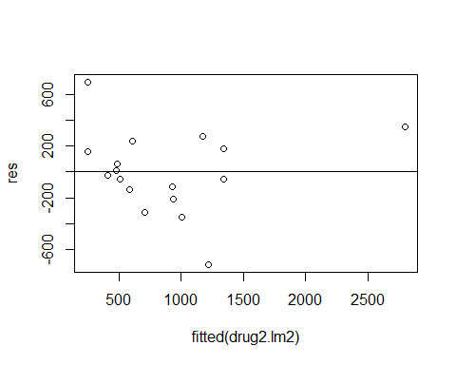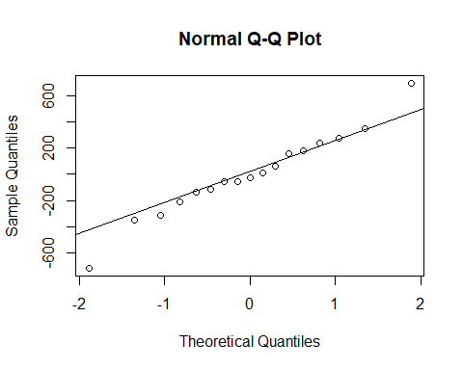

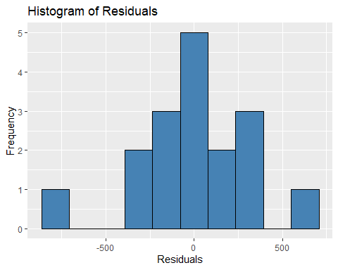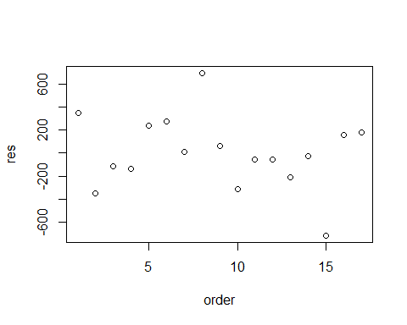

I would say the residuals are independent and follow a normal distribution, but I do spy an outlier or two.

Finally, the 95% prediction interval, where $z_{1}=1$, $z_{2}=1200$, $z_{3}=140$, $z_{4}=70$, and $z_{5}=85$.

## The 95% prediction interval is:

## fit lwr upr  
## 1 754.0677 -9.234071 1517.369

### 

### (c) Perform a multivariate multiple regression analysis using both responses $Y_{1}$ and $Y_{2}$.

## Response y1 :  
##   
## Call:  
## lm(formula = y1 ~ z1 + z2 + z3 + z4 + z5, data = drug)  
##   
## Residuals:  
## Min 1Q Median 3Q Max   
## -399.2 -180.1 4.5 164.1 366.8   
##   
## Coefficients:  
## Estimate Std. Error t value Pr(>|t|)   
## (Intercept) -2.879e+03 8.933e+02 -3.224 0.008108 **   
## z1 6.757e+02 1.621e+02 4.169 0.001565 **   
## z2 2.848e-01 6.091e-02 4.677 0.000675 ***  
## z3 1.027e+01 4.255e+00 2.414 0.034358 *   
## z4 7.251e+00 3.225e+00 2.248 0.046026 *   
## z5 7.598e+00 3.849e+00 1.974 0.074006 .   
## ---  
## Signif. codes: 0 '***' 0.001 '**' 0.01 '*' 0.05 '.' 0.1 ' ' 1  
##   
## Residual standard error: 281.2 on 11 degrees of freedom  
## Multiple R-squared: 0.8871, Adjusted R-squared: 0.8358   
## F-statistic: 17.29 on 5 and 11 DF, p-value: 6.983e-05  
##   
##   
## Response y2 :  
##   
## Call:  
## lm(formula = y2 ~ z1 + z2 + z3 + z4 + z5, data = drug)  
##   
## Residuals:  
## Min 1Q Median 3Q Max   
## -373.85 -247.29 -83.74 217.13 462.72   
##   
## Coefficients:  
## Estimate Std. Error t value Pr(>|t|)   
## (Intercept) -2.729e+03 9.288e+02 -2.938 0.013502 *   
## z1 7.630e+02 1.685e+02 4.528 0.000861 ***  
## z2 3.064e-01 6.334e-02 4.837 0.000521 ***  
## z3 8.896e+00 4.424e+00 2.011 0.069515 .   
## z4 7.206e+00 3.354e+00 2.149 0.054782 .   
## z5 4.987e+00 4.002e+00 1.246 0.238622   
## ---  
## Signif. codes: 0 '***' 0.001 '**' 0.01 '*' 0.05 '.' 0.1 ' ' 1  
##   
## Residual standard error: 292.4 on 11 degrees of freedom  
## Multiple R-squared: 0.8764, Adjusted R-squared: 0.8202   
## F-statistic: 15.6 on 5 and 11 DF, p-value: 0.0001132

For $Y_{1}$, I could drop $Z_{5}$; but for $Y_{2}$, I would drop the last three variables.

#### 

#### Suggest and fit appropriate linear regression models.

##   
## Type II MANOVA Tests: Pillai test statistic  
## Df test stat approx F num Df den Df Pr(>F)   
## z1 1 0.65521 9.5015 2 10 0.004873 **  
## z2 1 0.69097 11.1795 2 10 0.002819 **  
## z3 1 0.34649 2.6509 2 10 0.119200   
## z4 1 0.32381 2.3944 2 10 0.141361   
## z5 1 0.29184 2.0606 2 10 0.178092   
## ---  
## Signif. codes: 0 '***' 0.001 '**' 0.01 '*' 0.05 '.' 0.1 ' ' 1

It seems we will need to keep $Z_{1}$ and $Z_{2}$ for both of them.

## Response y1 :  
##   
## Call:  
## lm(formula = y1 ~ z1 + z2, data = drug)  
##   
## Residuals:  
## Min 1Q Median 3Q Max   
## -756.05 -190.68 -59.83 203.32 560.84   
##   
## Coefficients:  
## Estimate Std. Error t value Pr(>|t|)   
## (Intercept) 56.72005 206.70337 0.274 0.7878   
## z1 507.07308 193.79082 2.617 0.0203 *   
## z2 0.32896 0.04978 6.609 1.17e-05 ***  
## ---  
## Signif. codes: 0 '***' 0.001 '**' 0.01 '*' 0.05 '.' 0.1 ' ' 1  
##   
## Residual standard error: 358.6 on 14 degrees of freedom  
## Multiple R-squared: 0.7664, Adjusted R-squared: 0.733   
## F-statistic: 22.96 on 2 and 14 DF, p-value: 3.8e-05  
##   
##   
## Response y2 :  
##   
## Call:  
## lm(formula = y2 ~ z1 + z2, data = drug)  
##   
## Residuals:  
## Min 1Q Median 3Q Max   
## -716.80 -135.83 -23.16 182.27 695.97   
##   
## Coefficients:  
## Estimate Std. Error t value Pr(>|t|)   
## (Intercept) -241.34791 196.11640 -1.231 0.23874   
## z1 606.30967 183.86521 3.298 0.00529 **   
## z2 0.32425 0.04723 6.866 7.73e-06 ***  
## ---  
## Signif. codes: 0 '***' 0.001 '**' 0.01 '*' 0.05 '.' 0.1 ' ' 1  
##   
## Residual standard error: 340.2 on 14 degrees of freedom  
## Multiple R-squared: 0.787, Adjusted R-squared: 0.7566   
## F-statistic: 25.87 on 2 and 14 DF, p-value: 1.986e-05

#### Analyze the residuals

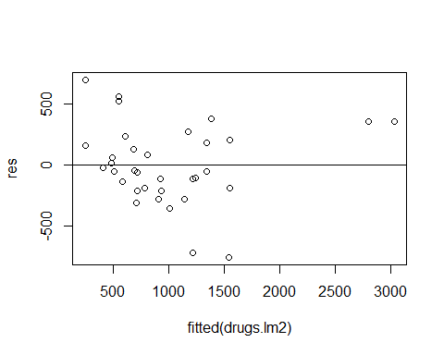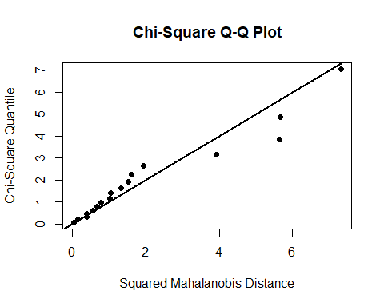

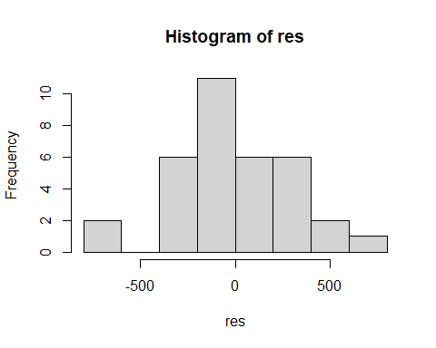

The residuals seem to be independent and follow a normal distribution.

#### (iii) Construct a 95% prediction ellipse for both Ttotal TCAD and Amount of amitriptyline for $z_{1}=1$, $z_{2}=1200$, $z_{3}=140$, $z_{4}=70$, and $z_{5}=85$. Compare this ellipse with the prediction intervals in (a) and (b). Comment.

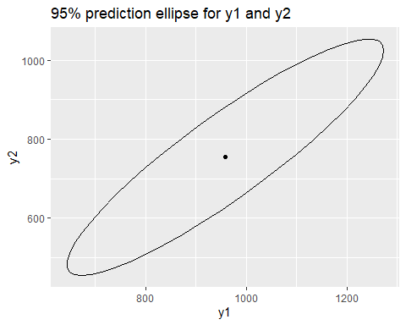

Comparing the ellipse to the prev two prediction intervals

## fit lwr upr  
## 1 958.5473 154.0402 1763.054

## fit lwr upr  
## 1 754.0677 -9.234071 1517.369

The ellipse is larger, but it is because we had to to make sure we had enough points to fit both the upper values. I can’t say for sure if we did consider our extremely small lower value for (b), but it does seem the ellipse fitted within those parameters.

**Code Appendix**

knitr::opts_chunk$set(echo = FALSE)  
library(car)  
library(dplyr)  
library(ggplot2)  
library(leaps)  
library(lmtest)  
library(matlib)  
library(MVN)  
library(SIBER)  
library(stats)  
fullMat <- c(10,5,7,19,11,18,  
 2,3,3,6,7,9,  
 15,9,3,25,7,13)  
full <- matrix(fullMat, nrow = 3, ncol = 6, byrow = TRUE)  
rownames(full)<- c("z1", "z2", "y")  
full  
n <- dim(full)[1]  
full1 <- as.data.frame(full)  
# function  
standardize = function(x){   
 z <- (x - mean(x)) / sqrt((n-1)*sd(x))  
 return(z)   
}   
# standardize   
full1 <- apply(full1, 2, standardize)   
cat("The standardized form of the variables are: \n")  
t(full1)  
# separate  
c1 <- t(full1[1,])  
c2 <- t(full1[2,])  
# means  
mc1 <- mean(c1)  
mc2 <- mean(c2)  
# cat  
cat("\nThe mean of z1 is", mc1, "\n")  
cat("The mean of z2 is", mc2, "\n")  
z1 <- t(full[1,])  
z2 <- t(full[2,])  
y <- t(full[3,])  
# means  
mean1 <- mean(z1)  
mean2 <- mean(z2)  
mean3 <- mean(y)  
# covariance  
fullCov <- cov(t(full))  
squareCov <- sqrt(fullCov)  
# cat  
cat("The mean for z1 is:", mean1, "\n")  
cat("The mean for z2 is:", mean2, "\n")  
cat("The mean for y is:", mean3, "\n")  
cat("The square root covariance matrix of the predictors is: \n")  
squareCov  
fullMat <- c(-2,-1,0,1,2,5,3,4,2,1,-3,-1,-1,2,3)  
full <- matrix(fullMat, nrow = 3, ncol = 5, byrow = TRUE)  
rownames(full)<- c("z1", "y1", "y2")  
full  
Zmat <- c(1,1,1,1,1,  
 -2,-1,0,1,2)  
Z <- matrix(Zmat, nrow = 2, ncol = 5, byrow = TRUE)  
cat("The Z matrix is \n")  
t(Z)  
# inverse  
prodZ <- Z %*% t(Z)   
invZ <- solve(prodZ)  
cat("\nThe inverse of Z'Z is \n")  
invZ  
b1 <- invZ %*% Z %*% full[2,]  
b2 <- invZ %*% Z %*% full[3,]  
b <- cbind(b1,b2)  
# print  
cat("Our least squares estimates matrix of our parameters is \n")  
b  
Yhat <- t(Z) %*% b  
Yhat  
y1 <- full[2,]  
y1 <- t(y1)  
y2 <- full[3,]  
y2 <- t(y2)  
y <- rbind(y1,y2)  
error <- t(y) - Yhat  
# print  
cat("The residual matrix is \n")  
error  
prodY <- y %*% t(y)  
cat("The Y'Y matrix is \n")  
prodY  
# hats  
prodHat <- t(Yhat) %*% Yhat   
prodError <- t(error) %*% error   
cat("\nThe right side of the equation is \n")  
prodHat + prodError  
muMat <- c(4,3,-2)  
mu <- matrix(muMat, nrow = 3, ncol = 1, byrow = TRUE)  
sigMat <- c(9,3,1,3,2,1,1,1,1)  
sigma <- matrix(sigMat, nrow = 3, ncol = 3, byrow = TRUE)  
cat("mu Matrix \n")  
mu  
cat("\n Sigma matrix \n")  
sigma  
muY <- mu[1,]  
muZ <- mu[2:3,]  
muZ <- muZ  
# sigma  
sYY <- sigma[1,1]  
ssZYmat <- c(3,1)  
ssZY <- matrix(ssZYmat, nrow = 1, ncol = 2, byrow = TRUE)  
sZY <- t(ssZY)  
sZZmat <- c(2,1,1,1)  
sZZ <- matrix(sZZmat, nrow = 2, ncol = 2, byrow = TRUE)  
# betas  
b <- inv(sZZ) %*% sZY  
b0 <- muY - (t(b) %*% muZ)  
# print  
cat("Our beta matrix is \n")  
b  
cat("\nBeta-0 is", b0)  
MSE <- sYY - ssZY %*% inv(sZZ) %*% sZY  
MSE  
pY <- sqrt((ssZY %*% inv(sZZ) %*% sZY)/sYY)  
pY  
sigma  
# partition  
s1mat <- c(9,3,3,2)  
s2mat <- c(1,1)  
s4 <- sigma[3,3]  
# matrix  
s1 <- matrix(s1mat, nrow = 2, ncol = 2, byrow = TRUE)  
s2 <- matrix(s2mat, nrow = 2, ncol = 1, byrow = TRUE)  
s3 <- matrix(s2mat, nrow = 1, ncol = 2, byrow = TRUE)  
# calculate  
mat <- s1 - (s2 %*% t(s4) %*% s3)  
# print  
cat("\nThe covariance matrix is \n")  
mat  
rho <- mat[1,2]/sqrt(mat[1,1] * mat[2,2])  
rho  
largeMat <- c(1, 108.28, 17.05, 1484.10,   
 2, 152.36, 16.59, 750.33,  
 3, 95.04, 10.91, 766.42,  
 4, 65.45, 14.14, 1110.46,  
 5, 62.97, 9.52, 1031.29,  
 6, 263.99, 25.33, 195.26,  
 7, 265.19, 18.54, 193.83,  
 8, 285.06, 15.73, 191.11,  
 9, 92.01, 8.10, 1175.16,  
 10, 165.68, 11.13, 211.15)  
large <- matrix(largeMat, nrow = 10, ncol = 4, byrow = TRUE)  
colnames(large) <- c("order", "sales", "profits", "assets")  
large  
large <- as.data.frame(large)  
sales <- large$sales  
profits <- large$profits  
assets <- large$assets  
order <- large$order  
# fit  
company <- lm(profits ~ sales + assets)  
summary(company)  
res <- resid(company)  
# plot  
plot(fitted(company), res)  
abline(0,0)  
# qq  
qqnorm(res)  
qqline(res)  
# histogram  
ggplot(data = large, aes(x = res)) +  
 geom_histogram(bins = 6,fill = 'steelblue', color = 'black') +  
 labs(title = 'Histogram of Residuals', x = 'Residuals', y = 'Frequency')  
# plot  
plot(order, res)  
com <- large[2:4]  
n <- dim(com)[1]  
p <- dim(com)[2]   
# leverage  
avg <- 3*(p/n)  
cat("The average leverage is", avg)  
hats <- as.data.frame(hatvalues(company))  
hats  
newCo <- data.frame(sales = 100, assets = 500)  
predict(company, newdata = newCo, interval = "prediction", level = 0.95)  
lineCo <- lm(profits ~ sales)  
lrtest(lineCo, company)  
bone <- read.table("D:/Coding/R Storage/T1-8.dat", header = FALSE)  
# names  
domRad <- bone$V1  
rad <- bone$V2  
domHum <- bone$V3  
hum <- bone$V4  
domUln <- bone$V5  
ulna <- bone$V6  
radius.lm <- lm(domRad ~ domHum + hum + domUln + ulna)  
summary(radius.lm)  
rad.lm1 <- lm(domRad ~ domHum + domUln + ulna)  
rad.lm2 <- lm(domRad ~ domHum)  
summary(rad.lm1)  
summary(rad.lm2)  
rad.lm3 <- lm(domRad ~ domHum + domUln)  
rad.lm4 <- lm(domRad ~ domHum + ulna)  
summary(rad.lm3)  
summary(rad.lm4)  
order <- c(1,2,3,4,5,6,7,8,9,10,11,12,13,14,15,16,17,18,19,20,21,22,23,24,25)  
bones <- cbind(order, bone)  
order <- bones$order  
res <- resid(rad.lm3)  
# plot  
plot(fitted(rad.lm3), res)  
abline(0,0)  
# qq  
qqnorm(res)  
qqline(res)  
# histogram  
ggplot(data = bone, aes(x = res)) +  
 geom_histogram(bins = 8,fill = 'steelblue', color = 'black') +  
 labs(title = 'Histogram of Residuals', x = 'Residuals', y = 'Frequency')  
# plot  
plot(order, res)  
rads.lm <- lm(cbind(domRad, rad)~ domHum + hum + domUln + ulna, data = bone)  
summary(rads.lm)  
rad.lm5 <- lm(rad ~ domHum + hum + domUln + ulna, data = bone)  
# AIC  
b <- AIC(rad.lm3)  
full <- AIC(rad.lm5)  
# print  
cat("The AIC for the model domRad = domHum + domUln is", b, "\n")  
cat("The AIC for the model rad = domHum + hum + domUln + ulna is", full)  
drug <- read.table("D:/Coding/R Storage/T7-6.dat", header = FALSE)  
# names  
y1 <- drug$V1  
y2 <- drug$V2  
z1 <- drug$V3  
z2 <- drug$V4  
z3 <- drug$V5  
z4 <- drug$V6  
z5 <- drug$V7  
drug1.lm1 <- lm(y1 ~ z1 + z2 + z3 + z4 + z5, data = drug)  
summary(drug1.lm1)  
anova(drug1.lm1)  
drug1.lm2 <- lm(y1 ~ z2, data = drug)  
summary(drug1.lm2)  
drug1.lm3 <- lm(y1 ~ z1 + z2, data = drug)  
summary(drug1.lm3)  
drug1.lm4 <- lm(y1 ~ z1 + z2 + z3, data = drug)  
drug1.lm5 <- lm(y1 ~ z1 + z2 + z3 + z4, data = drug)  
drug1.lm6 <- lm(y1 ~ z1, data = drug)  
summary(drug1.lm4)  
summary(drug1.lm5)  
summary(drug1.lm6)  
drug1.lm3  
order <- c(1,2,3,4,5,6,7,8,9,10,11,12,13,14,15,16,17)  
drugs <- cbind(order, drug)  
order <- drugs$order  
res <- resid(drug1.lm3)  
# plot  
plot(fitted(drug1.lm3), res)  
abline(0,0)  
# qq  
qqnorm(res)  
qqline(res)  
# histogram  
ggplot(data = drug, aes(x = res)) +  
 geom_histogram(bins = 10,fill = 'steelblue', color = 'black') +  
 labs(title = 'Histogram of Residuals', x = 'Residuals', y = 'Frequency')  
# plot  
plot(order, res)  
newD <- data.frame(z1 = 1, z2 = 1200, z3 = 140, z4 = 70, z5 = 85)  
pi1 <- predict(drug1.lm3, newdata = newD, interval = "prediction", level = 0.95)  
cat("The 95% prediction interval is: \n")  
pi1  
drug2.lm1 <- lm(y2 ~ z1 + z2 + z3 + z4 + z5, data = drug)  
anova(drug2.lm1)  
drug2.lm2 <- lm(y2 ~ z1 + z2, data = drug)  
summary(drug2.lm2)  
cat("\n Our model is \n")  
drug2.lm2  
res <- resid(drug2.lm2)  
# plot  
plot(fitted(drug2.lm2), res)  
abline(0,0)  
# qq  
qqnorm(res)  
qqline(res)  
# histogram  
ggplot(data = drug, aes(x = res)) +  
 geom_histogram(bins = 10,fill = 'steelblue', color = 'black') +  
 labs(title = 'Histogram of Residuals', x = 'Residuals', y = 'Frequency')  
# plot  
plot(order, res)  
pi2 <- predict(drug2.lm2, newdata = newD, interval = "prediction", level = 0.95)  
cat("The 95% prediction interval is: \n")  
pi2  
drugs.lm1 <- lm(cbind(y1, y2)~ z1 + z2 + z3 + z4 + z5, data = drug)  
summary(drugs.lm1)  
Anova(drugs.lm1)  
drugs.lm2 <- lm(cbind(y1, y2)~ z1 + z2, data = drug)  
summary(drugs.lm2)  
res <- resid(drugs.lm2)  
# plot  
plot(fitted(drugs.lm2), res)  
abline(0,0)  
# qq  
mvn(res, multivariatePlot = "qq")  
# histogram  
hist(res)  
confidenceEllipse <- function(mod, newdata, level = 0.95, ggplot = TRUE){  
# labels  
lev_lbl <- paste0(level * 100, "%")  
resps <- colnames(mod$coefficients)  
title <- paste(lev_lbl, "prediction ellipse for", resps[1], "and", resps[2])  
# prediction  
p <- predict(mod, newdata)  
# center of ellipse  
cent <- c(p[1,1],p[1,2])  
# shape of ellipse  
Z <- model.matrix(mod)  
Y <- mod$model[[1]]  
n <- nrow(Y)  
m <- ncol(Y)  
r <- ncol(Z) - 1  
S <- crossprod(resid(mod))/(n-r-1)  
# radius of circle generating the ellipse  
tt <- terms(mod)  
Terms <- delete.response(tt)  
mf <- model.frame(Terms, newdata, na.action = na.pass,  
 xlev = mod$xlevels)  
z0 <- model.matrix(Terms, mf, contrasts.arg = mod$contrasts)  
rad <- sqrt((m*(n-r-1)/(n-r-m)) * qf(level,m,n-r-m) *  
 z0 %*% solve(t(Z)%*%Z) %*% t(z0))  
 # generate ellipse using ellipse function in car package  
ell_points <- car::ellipse(center = c(cent), shape = S,  
 radius = c(rad), draw = FALSE)  
# ggplot2 plot  
if(ggplot){  
 ell_points_df <- as.data.frame(ell_points)  
 ggplot2::ggplot(ell_points_df, ggplot2::aes(.data[["x"]], .data[["y"]])) +  
 ggplot2::geom_path() +  
 ggplot2::geom_point(ggplot2::aes(x = .data[[resps[1]]],  
 y = .data[[resps[2]]]),  
 data = data.frame(p)) +  
 ggplot2::labs(x = resps[1], y = resps[2],  
 title = title)  
 } else {  
 # base R plot  
 plot(ell_points, type = "l",  
 xlab = resps[1], ylab = resps[2],  
 main = title)  
 points(x = cent[1], y = cent[2])  
 }  
}  
  
# ellipse  
confidenceEllipse(mod = drugs.lm2, newdata = newD)  
pi1  
cat("\n")  
pi2